**Objective Questions**

1. **List the different types of columns in table “ball_by_ball” (using information schema)**

**Ans:**

There are 11 columns present in the table “ball_by_ball”, which are fetched by the below query.

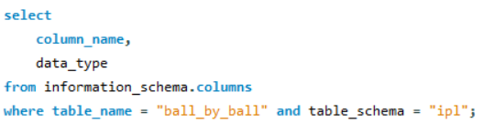

**Output:**

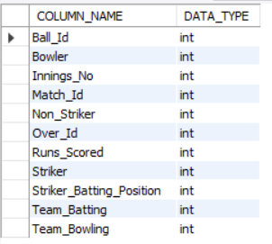

1. **What is the total number of runs scored in 1st season by RCB (bonus: also include the extra runs using the extra runs table)**

**Ans:**

with Score as (select

b.Match_id,

b.Over_Id,

b.Ball_Id,

b.Innings_No,

m.Season_Id,

b.Team_Batting,

t1.Team_Name as Batting_Team_Name,

b.Team_Bowling,

t2.Team_Name as Bowling_Team_Name,

b.Runs_Scored,

coalesce(e.Extra_Runs,0) as Extra_Runs

from ball_by_ball b join team t1

on t1.Team_Id = b.Team_Batting

join team t2 on t2.Team_Id = b.Team_Bowling

join matches m on m.Match_Id = b.Match_Id

left join extra_runs e on e.Match_Id = b.Match_Id

and e.Over_Id = b.Over_Id

and e.Ball_Id = b.Ball_Id

and e.Innings_No = b.Innings_No)

select

sum(Runs_Scored + Extra_Runs) as Total_Runs

from Score

where Season_Id = (select min(Season_Id) from Score)

and Batting_Team_Name = "Royal Challengers Bangalore";

**Output:**



1. **How many players were more than the age of 25 during season 2014?**

**Ans:**

with playercount as (select

count(distinct p.Player_Id) as PlayerCountAbove25,

s.Season_Id,

s.Season_Year

from player p join player_match pm

on p.Player_Id = pm.Player_Id

join matches m on m.Match_Id = pm.Match_Id

join season s on s.Season_Id = m.Season_Id

where s.Season_Year = 2014

and timestampdiff(year, p.DOB, m.Match_Date) > 25

group by s.Season_Id, s.Season_Year)

select

PlayerCountAbove25

from playercount;

**Output:**



1. **How many matches did RCB win in 2013?**

**Ans:**

select

t.team_Id,

t.Team_Name,

count(m.Match_Winner) as win_count

from matches m join season s

on s.Season_Id = m.Season_Id

join team t

on m.Match_Winner = t.Team_Id

where t.Team_Name = "Royal Challengers Bangalore"

and Season_Year = 2013

group by t.team_Id;

**Output:**



1. **List the top 10 players according to their strike rate in the last 4 seasons**

**Ans:**

with seasonYear as (select

Season_Year

from season

order by Season_Year desc

limit 4)

select

p.Player_Name,

sum(b.Runs_Scored) as totalRuns,

nullif(count(b.Ball_Id),0) as balls_faced,

round((sum(b.Runs_Scored) * 100 )/ nullif(count(b.Ball_Id),0),2) as strike_rate

from ball_by_ball b join matches m on b.Match_Id = m.Match_Id

join player p on p.Player_Id = b.Striker

join season s on s.Season_Id = m.Season_Id

join seasonYear sy on sy.Season_Year = s.Season_Year

left join extra_runs e on e.Match_Id = b.Match_Id

and e.Over_Id = b.Over_Id

and e.Ball_Id = b.Ball_Id

and e.Innings_No = b.Innings_No

where e.Extra_Runs is null

group by p.Player_Name, b.Striker

order by strike_rate desc

limit 10;

**Output:**

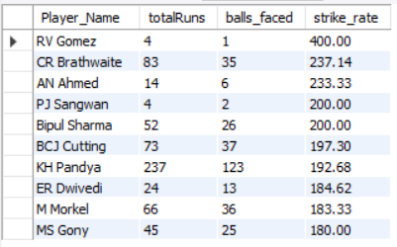

1. **What are the average runs scored by each batsman considering all the seasons?**

**Ans:**

select

p.player_name,

round(sum(b.runs_scored)/ count(distinct Match_Id), 2) as average_runs

from ball_by_ball b

join player p on p.player_id = b.striker

group by p.player_name

order by average_runs desc;

**Output:**

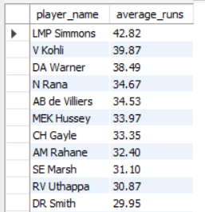

1. **What are the average wickets taken by each bowler considering all the seasons?**

**Ans:**

select

p.Player_Name,

count(wc.Player_Out) as wickets,

count(distinct b.Match_Id) as Matches_played,

round(count(wc.Player_Out)/count(distinct b.Match_Id),2) as avg_wickets_taken

from wicket_taken wc left join ball_by_ball b

on wc.Match_Id = b.Match_Id

and wc.Over_Id = b.Over_Id

and wc.Ball_Id = b.Ball_Id

and wc.Innings_No = b.Innings_No

join player p on p.Player_Id = b.Bowler

group by p.Player_Name

order by avg_wickets_taken desc;

**Output:**

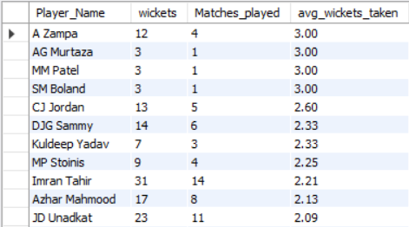

1. **List all the players who have average runs scored greater than the overall average and who have taken wickets greater than the overall average**

**Ans:**

with avg_runs as (select

p.player_name,

round(sum(b.runs_scored)*1.0 / count(distinct Match_Id), 2) as average_runs

from ball_by_ball b

join player p on p.player_id = b.striker

group by p.player_name),

overall_avg_runs as (select

avg(average_runs) as overall_ar

from avg_runs),

avg_wickets as (select

p.Player_Name,

round(count(wc.Player_Out)* 1.0/count(distinct b.Match_Id),2) as avg_wickets_taken

from wicket_taken wc left join ball_by_ball b

on wc.Match_Id = b.Match_Id

and wc.Over_Id = b.Over_Id

and wc.Ball_Id = b.Ball_Id

and wc.Innings_No = b.Innings_No

join player p on p.Player_Id = b.Bowler

group by p.Player_Name),

overall_avg_wickets as (select

avg(avg_wickets_taken) as overall_aw

from avg_wickets)

select

ar.Player_Name

from avg_runs ar join avg_wickets aw

on ar.Player_Name = aw.Player_Name

join overall_avg_runs oar on ar.average_runs > oar.overall_ar

join overall_avg_wickets oaw on aw.avg_wickets_taken > oaw.overall_aw;

**Output:**

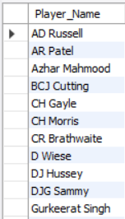

1. **Create a table rcb_record table that shows the wins and losses of RCB in an individual venue.**

**Ans:**

create table rcb_record as (select

v.Venue_Name,

count(*) as total_matches,

sum(case when m.Match_Winner = t.Team_Id then 1 else 0 end) as wins,

sum(case when m.Match_Winner <> Team_Id and (m.Team_1 = Team_Id or m.Team_2 = Team_Id) then 1 else 0 end) as losses,

sum(case when m.Match_Winner is null then 1 else 0 end) as no_result

from venue v join matches m on v.Venue_Id = m.Venue_Id

join team t on t.Team_Name = "Royal Challengers Bangalore"

where (t.Team_Id = m.Team_1 or t.Team_Id = m.Team_2)

group by v.Venue_Name);

select * from rcb_record;

**Output:**

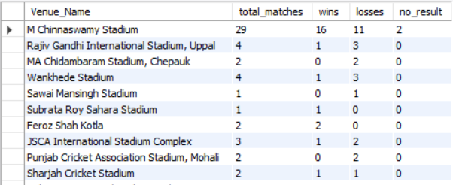

1. **What is the impact of bowling style on wickets taken?**

**Ans:**

select

bs.Bowling_skill as bowling_style,

count(w.Player_Out) as total_wickets

from ball_by_ball b join wicket_taken w

on w.Match_Id = b.Match_Id

and w.Over_Id = b.Over_Id

and w.Ball_Id = b.Ball_Id

and w.Innings_No = b.Innings_No

join player p on p.Player_Id = b.Bowler

join bowling_style bs on bs.Bowling_Id = p.Bowling_skill

group by bs.Bowling_skill

order by total_wickets desc;

**Output:**

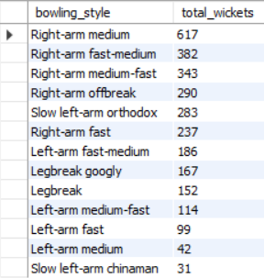

1. **Write the SQL query to provide a status of whether the performance of the team is better than the previous year's performance on the basis of the number of runs scored by the team in the season and the number of wickets taken**

**Ans:**

with team_performance as (select

t.Team_Name,

s.Season_Year,

sum(b.Runs_Scored) as Runs_scored,

count(w.Player_Out) as Wickets_taken

from team t join player_match p on p.Team_Id = t.Team_Id

join matches m on m.Match_Id = p.Match_Id

join season s on s.Season_Id = m.Season_Id

left join ball_by_ball b on b.Match_Id = p.Match_Id and b.Striker = p.Player_Id

left join ball_by_ball b1 on b1.Match_Id = p.Match_Id and b1.Bowler = p.Player_Id

left join wicket_taken w on w.Match_Id = b1.Match_Id and w.Over_Id = b1.Over_Id

and w.Ball_Id = b1.Ball_Id and w.Innings_No = b1.Innings_No

group by t.Team_Name, s.Season_Year)

select

t1.Team_Name,

t1.Season_Year as Previous_year,

t2.Season_Year as Current_Year,

t1.Runs_scored as Previous_year_runs,

t2.Runs_scored as Current_year_runs,

t1.Wickets_taken as Previous_year_wickets,

t2.Wickets_taken as Current_year_Wickets,

case

when t2.Runs_scored > t1.Runs_scored and t2.Wickets_taken > t1.Wickets_taken then "Overall Improved"

when t2.Runs_scored = t1.Runs_scored and t2.Wickets_taken = t1.Wickets_taken then "Same"

when t2.Runs_scored > t1.Runs_scored and t2.Wickets_taken <=t1.Wickets_taken then "Batting Improved"

when t2.Runs_scored < t1.Runs_scored and t2.Wickets_taken >= t1.Wickets_taken then "Wickets Improved"

else "Worse"

end as Performance_status

from team_performance t1 join team_performance t2

on t1.Team_Name = t2.Team_Name and t1.Season_Year = t2.Season_Year - 1

order by t1.Team_Name, t1.Season_Year;

**Output:**

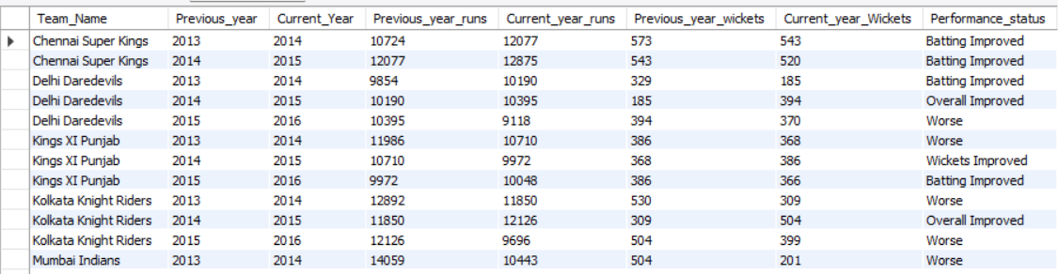

1. **Can you derive more KPIs for the team strategy?**

**Ans:**

1. **Boundary Frequency Percentage**

select

p.Player_Name,

(sum(case when b.Runs_Scored in (4,6) then 1 else 0 end)* 100 / count(*)) as Boundary_frequency

from player p join ball_by_ball b

on p.Player_Id = b.Striker

group by p.Player_Name

order by Boundary_frequency desc;

1. **Death Over Performance**

select

P.Player_Name as Batsman_Name,

p1.Player_Name as Bowler_Name,

t.Team_Name as Batting_team,

t1.Team_Name as Bowler_team,

sum(b.Runs_Scored) as Death_over_runs,

count(w.Player_Out) as Death_over_wickets

from ball_by_ball b left join wicket_taken w

on b.Match_Id = w.Match_Id

and b.Over_Id = w.Over_Id

and b.Ball_Id = w.Ball_Id

and b.Innings_No = w.Innings_No

join team t on t.Team_Id = b.Team_Batting join team t1 on t1.Team_Id = b.Team_Bowling

join player p on p.Player_Id = b.Striker join player p1 on p1.Player_Id = b.Bowler

where b.Over_Id between 17 and 20

group by p.Player_Name, t.Team_Name, p1.Player_Name, t1.Team_Name, b.Team_Batting, b.Team_Bowling

order by Death_over_runs desc, Death_over_wickets desc;

1. **Powerplay performance**

select

P.Player_Name as Batsman_Name,

p1.Player_Name as Bowler_Name,

t.Team_Name as Batting_team,

t1.Team_Name as Bowler_team,

sum(b.Runs_Scored) as Powerplay_runs,

count(w.Player_Out) as Powerplay_wickets

from ball_by_ball b left join wicket_taken w

on b.Match_Id = w.Match_Id

and b.Over_Id = w.Over_Id

and b.Ball_Id = w.Ball_Id

and b.Innings_No = w.Innings_No

join team t on t.Team_Id = b.Team_Batting join team t1 on t1.Team_Id = b.Team_Bowling

join player p on p.Player_Id = b.Striker join player p1 on p1.Player_Id = b.Bowler

where b.Over_Id between 1 and 6

group by p.Player_Name, t.Team_Name, p1.Player_Name, t1.Team_Name, b.Team_Batting, b.Team_Bowling

order by Powerplay_runs desc, Powerplay_wickets desc;

1. **Average Contribution by top order**

with first_three_batters as (select

distinct Match_Id,

Team_Batting,

Striker

from (select

Match_Id,

Team_Batting,

Striker,

row_number() over(partition by Match_Id, Team_Batting order by Over_Id, Ball_Id) as entry_order

from ball_by_ball) rs where entry_order <=3),

top_order_stats as (select

m.Match_Id,

t.Team_Name,

sum(case when f.Striker is not null then b.Runs_Scored else 0 end) as top_order_runs,

sum(b.Runs_Scored) as match_total_runs

from matches m join ball_by_ball b on m.Match_Id = b.Match_Id

join team t on t.Team_Id = b.Team_Batting

left join first_three_batters f on f.Match_Id = b.Match_Id

and f.Team_Batting = b.Team_Batting and f.Striker = b.Striker

group by m.Match_Id, t.Team_Name)

select

Team_Name,

round(avg((top_order_runs * 1.0 / match_total_runs)* 100),2) as Avg_Top_Order_Contribution

from top_order_stats

group by Team_Name

order by Avg_Top_Order_Contribution desc;

1. **Powerplay Strike Rate**

select

p.Player_Name,

round(sum(b.Runs_Scored)*100/count(*),2) as Strike_Rate

from ball_by_ball b join player p

on p.Player_Id = b.Striker

where b.Over_Id between 1 and 6

group by p.Player_Name

having count(*) > 20

order by Strike_Rate desc;

**Output:**

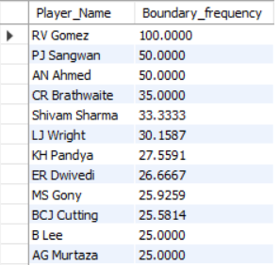

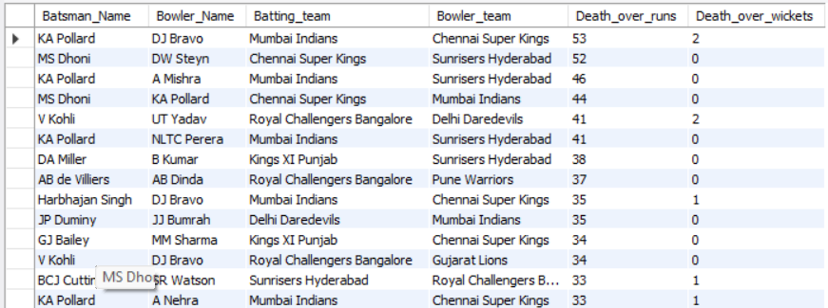

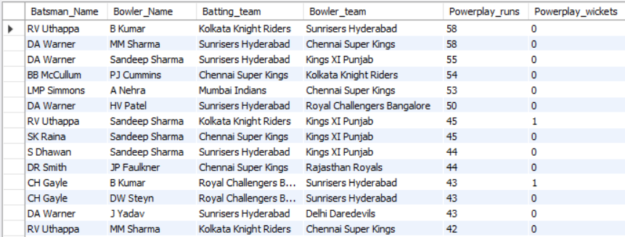

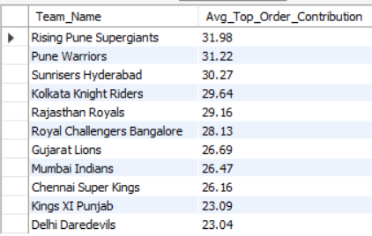

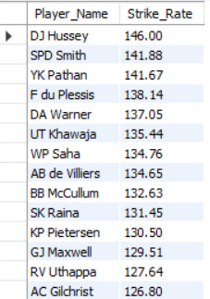

1. **Using SQL, write a query to find out the average wickets taken by each bowler in each venue. Also, rank the gender according to the average value.**

**Ans:**

with wickets_per_venue as (

select

p.player_id,

p.player_name,

v.venue_name,

count(wt.player_out) as total_wickets,

count(distinct m.match_id) as total_matches,

round(count(wt.player_out) * 1.0 / count(distinct m.match_id), 2) as avg_wickets

from player p

join ball_by_ball bb on p.player_id = bb.bowler

join matches m on bb.match_id = m.match_id

join wicket_taken wt on bb.match_id = wt.match_id

and bb.over_id = wt.over_id

and bb.ball_id = wt.ball_id

join venue v on m.venue_id = v.venue_id

group by p.player_id, p.player_name, v.venue_name

)

select

player_id,

player_name,

venue_name,

total_wickets,

total_matches,

avg_wickets,

rank() over (order by avg_wickets desc) as wicket_rank

from wickets_per_venue

order by wicket_rank;

**Output:**

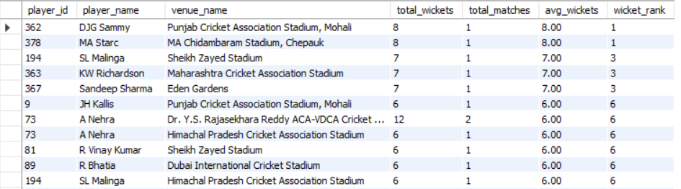

1. **Which of the given players have consistently performed well in past seasons? (will you use any visualization to solve the problem)**

**Ans:**

with player_season_performance as (select

p.Player_Name,

s.Season_Year,

sum(case when b.Striker = p.Player_Id then b.Runs_Scored else 0 end) as total_runs,

count(distinct case when w.Player_Out = p.Player_Id then b.Match_Id else 0 end) as total_wickets

from player p left join ball_by_ball b

on p.Player_Id = b.Striker or p.Player_Id = b.Bowler

left join matches m on m.Match_Id = b.Match_Id

left join season s on s.Season_Id = m.Season_Id

left join wicket_taken w

on b.Match_Id = w.Match_Id

and b.Over_Id = w.Over_Id

and b.Ball_Id = w.Ball_Id

and b.Innings_No = w.Innings_No

group by p.Player_Name, s.Season_Year)

select

Player_Name,

count(distinct Season_Year) as Seasons_Played,

round(avg(total_runs),2) as avg_runs_per_season,

round(avg(total_wickets),2) as avg_wickets_per_season

from player_season_performance

group by Player_Name

having count(distinct Season_Year) > 2

order by avg_runs_per_season desc, avg_wickets_per_season desc;

**Output:**

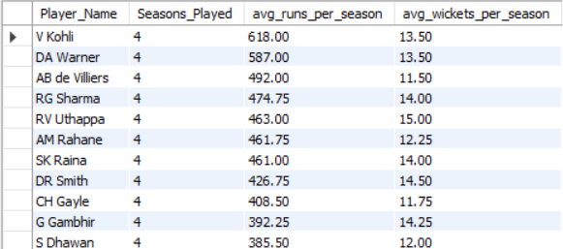

**Chart:**

1. **Are there players whose performance is more suited to specific venues or conditions? (how would you present this using charts?)**

**Ans:**

with player_venue_performance as (select

p.Player_Name,

v.Venue_Name,

sum(case when b.Striker = p.Player_Id then b.Runs_Scored else 0 end) as total_runs,

count(distinct case when w.Player_Out = p.Player_Id then b.Match_Id else 0 end) as total_wickets

from player p left join ball_by_ball b

on p.Player_Id = b.Striker or p.Player_Id = b.Bowler

left join matches m on m.Match_Id = b.Match_Id

left join venue v on v.Venue_Id = m.Venue_Id

left join wicket_taken w

on b.Match_Id = w.Match_Id

and b.Over_Id = w.Over_Id

and b.Ball_Id = w.Ball_Id

and b.Innings_No = w.Innings_No

group by p.Player_Name, v.Venue_Name)

select

Player_Name,

Venue_Name,

round(avg(total_runs),2) as avg_runs,

round(avg(total_wickets),2) as avg_wickets

from player_venue_performance

group by Player_Name, Venue_Name

having round(avg(total_runs),2) > 30

and round(avg(total_wickets),2) > 5

order by avg_runs desc, avg_wickets desc;

**Output:**

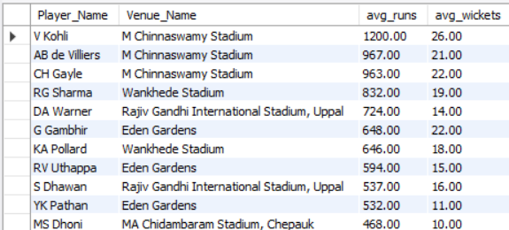

**Chart:**

**Subjective** **Questions**

1. **How does the toss decision affect the result of the match? (which visualizations could be used to present your answer better) And is the impact limited to only specific venues?**

**Tables Used:**

Venue, matches, team, toss_decision

**Approach:**

* + Check if toss winner = match winner
  + Group by venue and toss decision
  + Calculate total matches, matches won after toss, and win percentage

**Insights**

* + Toss impacts match results, but the effect varies by venue
  + Some venues heavily favor batting/fielding first
  + Toss may give a significant edge in specific conditions (e.g., dew at night)

**Recommendations**

* + Use historical data to guide toss decisions
  + Tailor strategies based on venue-specific toss trends
  + Further analyze by match format or season for deeper insights

**Query:**

select

v.Venue_Name,

t.Toss_Name as toss_decision,

count(*) as Total_matches,

sum(case when m.Toss_Winner = m.Match_Winner then 1 else 0 end) as matches_won_after_toss,

round(sum(case when m.Toss_Winner = m.Match_Winner then 1 else 0 end) *100 / count(*),2) as win_percentage

from venue v join matches m on v.Venue_Id = m.Venue_Id

join team tm on tm.Team_Id = m.Toss_Winner

join toss_decision t on t.Toss_Id = m.Toss_Decide

where m.Match_Winner is not null

group by v.Venue_Name, t.Toss_Name

order by Total_matches desc, win_percentage desc;

**Output:**

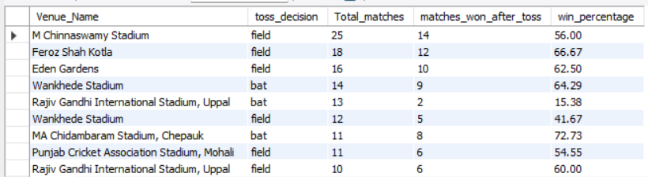

**Chart:**

1. **Suggest some of the players who would be best fit for the team.**

**Tables Used:**

Player, ball_by_ball, wicket_taken, matches, season

**Approach:**

* Create a CTE to calculate:
  + Total runs scored per player per season
  + Total wickets taken per player per season
* Group by Player_Name and Season_Year
* Calculate:
  + Number of seasons played
  + Average runs per season
  + Average wickets per season
* Filter players who played more than 2 seasons
* Order results by average runs and then average wickets

**Insights:**

* Identifies **consistent top-performing players** across multiple seasons
* Highlights **batting all-rounders** and dual contributors
* Helps filter out one-season wonders and prioritize long-term performance

**Recommendations:**

* Select **players with high average runs and decent wickets** for formats like T20/ODI
* Use this analysis to build a **balanced team of specialists and all-rounders**
* Add more metrics like strike rate, economy rate, and recent season form for finer selection
* Customize based on **format-specific needs** (e.g., explosive batsmen for T20)

**Query:**

with player_season_performance as (select

p.Player_Name,

s.Season_Year,

sum(case when b.Striker = p.Player_Id then b.Runs_Scored end) as total_runs,

count(distinct case when w.Player_Out = p.Player_Id then b.Match_Id else 0 end) as total_wickets

from player p left join ball_by_ball b

on p.Player_Id = b.Striker or p.Player_Id = b.Bowler

left join matches m on m.Match_Id = b.Match_Id

left join season s on s.Season_Id = m.Season_Id

left join wicket_taken w

on b.Match_Id = w.Match_Id

and b.Over_Id = w.Over_Id

and b.Ball_Id = w.Ball_Id

and b.Innings_No = w.Innings_No

group by p.Player_Name, s.Season_Year)

select

Player_Name,

count(distinct Season_Year) as Seasons_Played,

round(avg(total_runs),2) as avg_runs_per_season,

round(avg(total_wickets),2) as avg_wickets_per_season

from player_season_performance

group by Player_Name

having count(distinct Season_Year) > 2

order by avg_runs_per_season desc, avg_wickets_per_season desc;

**Output:**

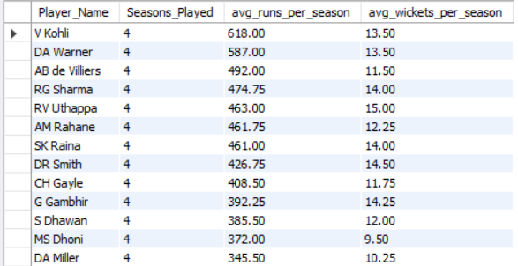

1. **What are some of the parameters that should be focused on while selecting the players?**

**Tables Used:**

player, player_match, matches, ball_by_ball, wicket_taken

**Approach:**

* Use a **CTE (player_stats)** to gather comprehensive player statistics
* For each player:
  + Count **matches played**
  + Sum **total runs** scored and **balls faced** (batting)
  + Count **balls bowled**, **runs conceded**, and **wickets taken** (bowling)
* Calculate:
  + **Strike rate** = (Total Runs × 100) / Balls Faced
  + **Economy rate** = (Runs Conceded × 100) / Balls Bowled
* Order results to highlight **top-performing players**

**Insights:**

* Players with **high strike rates** and **low economy rates** are ideal for shorter formats (T20, ODI)
* High **run scorers** and **wicket-takers** consistently contribute to match outcomes
* **All-rounders** (good in both batting & bowling) can be easily identified from this data

**Recommendations:**

* + Pick batters with high **strike rate** and **total runs**.
  + Choose bowlers with low **economy rate** and high **wicket count**.
  + Prefer players with **consistent performance** over multiple matches.
  + Include **all-rounders** for team balance.
  + Prioritize players with good **match experience**.

**Query:**

with player_stats as (select

p.Player_Name,

count(distinct m.Match_Id) as matches_played,

sum(case when b.Striker = p.Player_Id then b.Runs_Scored else 0 end) as total_runs,

count(case when b.Striker = p.Player_Id then 1 end) as balls_faced,

count(case when b.Bowler = p.Player_Id then 1 end) as balls_bowled,

sum(case when b.Bowler = p.Player_Id then b.Runs_Scored else 0 end) as runs_conceded,

count(case when wt.Player_Out = p.Player_Id then 1 end) as wickets_taken

from player p join player_match pm

on p.Player_Id = pm.Player_Id

join matches m on m.Match_Id = pm.Match_Id

left join ball_by_ball b on b.Match_Id = m.Match_Id

and (b.Striker = p.Player_Id or b.Bowler = p.Player_Id)

left join wicket_taken wt on wt.Match_Id = b.Match_Id

and wt.Over_Id = b.Over_Id

and wt.Ball_Id = b.Ball_Id

and wt.Innings_No = b.Innings_No

group by p.Player_Name)

select

Player_Name,

matches_played,

total_runs,

balls_faced,

round(case when balls_faced > 0 then (total_runs * 100) / balls_faced else 0 end, 2) as strike_rate,

wickets_taken,

balls_bowled,

round(case when balls_bowled > 0 then (runs_conceded * 100) / balls_bowled else 0 end, 2) as economy_rate

from player_stats

order by total_runs desc, wickets_taken desc;

**Output:**

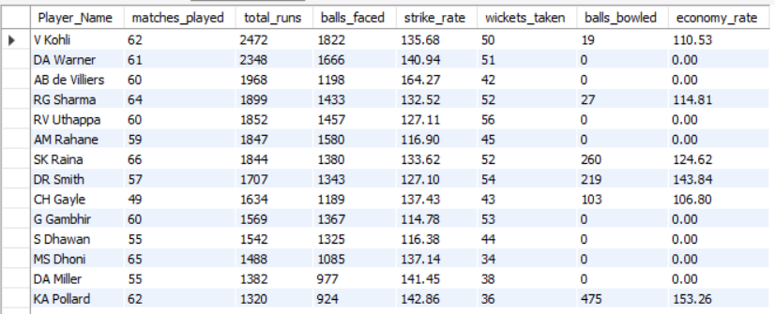

1. **Which players offer versatility in their skills and can contribute effectively with both bat and ball? (can you visualize the data for the same)**

**Tables used:**

player, player_match, matches, ball_by_ball, wicket_taken

**Approach:**

* Join all relevant tables to gather batting and bowling actions by player.
* Calculate per player:
  + total_runs, balls_faced, strike_rate
  + wickets_taken, balls_bowled, runs_conceded, economy_rate
* Filter for:
  + total_runs > 500
  + wickets_taken > 20
* Sort by highest runs and wickets to get top all-rounders.

**Insights:**

* Identifies **true all-rounders** who contribute significantly with both bat and ball.
* Players with high **strike rate + low economy rate** are key assets in T20/ODI.
* Only a few players meet both thresholds, highlighting rarity and value.

**Recommendations:**

* Focus on players with **balanced performance**: >500 runs & >20 wickets.
* Select all-rounders to **increase squad depth** and adapt to match scenarios.
* Use these metrics for **auction picks, team drafts, or match strategy**.
* Visualize using a **scatter plot** of Runs vs Wickets to spot top contributors easily.

**Query:**

with player_stats as (select

p.Player_Name,

count(distinct m.Match_Id) as matches_played,

sum(case when b.Striker = p.Player_Id then b.Runs_Scored else 0 end) as total_runs,

count(case when b.Striker = p.Player_Id then 1 end) as balls_faced,

count(case when b.Bowler = p.Player_Id then 1 end) as balls_bowled,

sum(case when b.Bowler = p.Player_Id then b.Runs_Scored else 0 end) as runs_conceded,

count(case when wt.Player_Out = p.Player_Id then 1 end) as wickets_taken

from player p join player_match pm

on p.Player_Id = pm.Player_Id

join matches m on m.Match_Id = pm.Match_Id

left join ball_by_ball b on b.Match_Id = m.Match_Id

and (b.Striker = p.Player_Id or b.Bowler = p.Player_Id)

left join wicket_taken wt on wt.Match_Id = b.Match_Id

and wt.Over_Id = b.Over_Id

and wt.Ball_Id = b.Ball_Id

and wt.Innings_No = b.Innings_No

group by p.Player_Name)

select

Player_Name,

matches_played,

total_runs,

balls_faced,

round(case when balls_faced > 0 then (total_runs * 100) / balls_faced else 0 end, 2) as strike_rate,

wickets_taken,

balls_bowled,

round(case when balls_bowled > 0 then (runs_conceded * 100) / balls_bowled else 0 end, 2) as economy_rate

from player_stats

where total_runs > 500 and wickets_taken > 20

order by total_runs desc, wickets_taken desc;

**Output:**

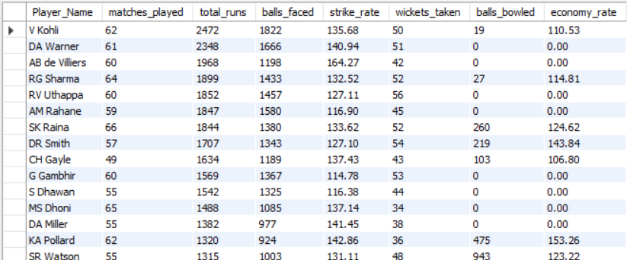

1. **Are there players whose presence positively influences the morale and performance of the team? (justify your answer using visualization)**

**Tables Used:**

player_match, matches, team, player

**Approach:**

* Join **match** and **player participation** data.
* Count **total matches** each player has played for a **team**.
* Count **wins** where the player's team was the **match winner**.
* Calculate **win percentage** when the player was in the **playing XI**.
* Filter players with **more than 10 matches**.
* Order by **highest win percentage**.

**Insights:**

* Players with **high match win percentages** likely **boost team morale and performance**.
* A consistently **high win rate** suggests a **positive impact** on outcomes.
* Such players may act as **match-winners** or **key motivators**.

**Recommendations:**

* Retain players with **high win percentages** in the **core squad**.
* Use them in **crucial matches** to leverage their **influence**.
* Analyze their **roles, leadership, or field positions** contributing to wins.
* Consider for **captaincy** or **mentorship roles**.

**Query:**

select

p.Player_Name,

t.Team_Name,

count(distinct pm.Match_Id) as matches_played,

sum(case when m.Match_Winner = pm.Team_Id then 1 else 0 end) as matches_won,

round(100 * sum(case when m.Match_Winner = pm.Team_Id then 1 else 0 end) / count(distinct pm.Match_Id), 2) as matches_won_percentage

from player_match pm join matches m

on pm.Match_Id = m.Match_Id

join team t on t.Team_Id = pm.Team_Id

join player p on p.Player_Id = pm.Player_Id

where m.Match_Winner is not null

group by p.Player_Name, t.Team_Name

having count(distinct pm.Match_Id) > 10

order by matches_won_percentage desc;

**Output:**

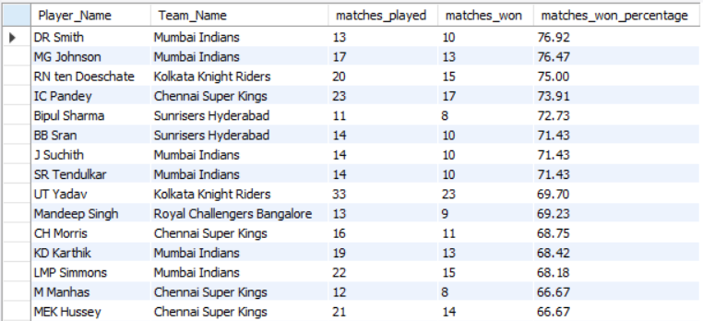

1. **What would you suggest to RCB before going to the mega auction?**

•**Invest in Versatile Players**

* Target players who have **500+ runs and 20+ wickets** over seasons.
* All-rounders improve team balance and flexibility.

• **Retain Players with High Impact**

* Look at players with **70%+ win percentage** when in the team.
* Such players positively influence match outcomes and team morale.

• **Strengthen Middle Order & Death Bowling**

* Consistent failure in these areas has cost matches.
* Invest in **finishers** and **death-over specialists**.

• **Optimize Toss-Based Strategy**

* Analyze past results by **venue and toss decision**.
* Pick players who can adapt to **batting/fielding first conditions**.

• **Focus on Youth + Experience Mix**

* Blend of young Indian talent and seasoned international players ensures **depth and adaptability**.

1. **What do you think could be the factors contributing to the high-scoring matches and the impact on viewership and team strategies**

**Factors Contributing to High-Scoring Matches:**

**1. Home Ground Influence**

* **Approach:** Analyze average team scores at each venue, especially for home teams.
* **Insight:** Smaller grounds and flat pitches (e.g., Chinnaswamy, Wankhede) consistently produce high scores; home teams perform better due to pitch familiarity.
* **Recommendation:** Build squads tailored to home conditions and leverage pitch behavior when planning strategies and team selection.

**2. Toss Decision Impact**

* **Approach:** Compare outcomes based on toss decisions (batting vs. fielding first), considering time of day and dew factor.
* **Insight:** Teams prefer chasing in night matches due to dew aiding batting; batting first works better on dry or turning pitches.
* **Recommendation:** Make toss decisions based on pitch reports and weather conditions; prepare for both scenarios with adaptable strategies.

**3. Powerplay Performance (Overs 1–6)**

* **Approach:** Evaluate run rate and wicket loss during Powerplay across teams.
* **Insight:** A quick start (50+ runs) often leads to high totals and sets the tone for the innings.
* **Recommendation:** Use aggressive openers to exploit fielding restrictions and gain early momentum.

**4. Death Over Performance (Overs 16–20)**

* **Approach:** Measure runs scored and economy rates in the final 5 overs.
* **Insight:** The death overs contribute significantly (25–30%) to the final score; a strong finish can swing the match.
* **Recommendation:** Train explosive finishers and use experienced bowlers with death-over skills (yorkers, slower balls, etc.).

**Query:**

**1. Home-ground influence**

with player_venue_performance as (select

p.Player_Name,

v.Venue_Name,

sum(case when b.Striker = p.Player_Id then b.Runs_Scored else 0 end) as total_runs,

count(distinct case when w.Player_Out = p.Player_Id then b.Match_Id else 0 end) as total_wickets

from player p left join ball_by_ball b

on p.Player_Id = b.Striker or p.Player_Id = b.Bowler

left join matches m on m.Match_Id = b.Match_Id

left join venue v on v.Venue_Id = m.Venue_Id

left join wicket_taken w

on b.Match_Id = w.Match_Id

and b.Over_Id = w.Over_Id

and b.Ball_Id = w.Ball_Id

and b.Innings_No = w.Innings_No

group by p.Player_Name, v.Venue_Name)

select

Player_Name,

Venue_Name,

round(avg(total_runs),2) as avg_runs,

round(avg(total_wickets),2) as avg_wickets

from player_venue_performance

group by Player_Name, Venue_Name

having round(avg(total_runs),2) > 30

and round(avg(total_wickets),2) > 5

order by avg_runs desc, avg_wickets desc;

**2. Toss-decision impact**

select

v.Venue_Name,

t.Toss_Name as toss_decision,

count(*) as Total_matches,

sum(case when m.Toss_Winner = m.Match_Winner then 1 else 0 end) as matches_won_after_toss,

round(sum(case when m.Toss_Winner = m.Match_Winner then 1 else 0 end) *100 / count(*),2) as win_percentage

from venue v join matches m on v.Venue_Id = m.Venue_Id

join team tm on tm.Team_Id = m.Toss_Winner

join toss_decision t on t.Toss_Id = m.Toss_Decide

where m.Match_Winner is not null

group by v.Venue_Name, t.Toss_Name

order by Total_matches desc, win_percentage desc;

**3. Death Over Performance**

select

P.Player_Name as Batsman_Name,

p1.Player_Name as Bowler_Name,

t.Team_Name as Batting_team,

t1.Team_Name as Bowler_team,

sum(b.Runs_Scored) as Death_over_runs,

count(w.Player_Out) as Death_over_wickets

from ball_by_ball b left join wicket_taken w

on b.Match_Id = w.Match_Id

and b.Over_Id = w.Over_Id

and b.Ball_Id = w.Ball_Id

and b.Innings_No = w.Innings_No

join team t on t.Team_Id = b.Team_Batting join team t1 on t1.Team_Id = b.Team_Bowling

join player p on p.Player_Id = b.Striker join player p1 on p1.Player_Id = b.Bowler

where b.Over_Id between 17 and 20

group by p.Player_Name, t.Team_Name, p1.Player_Name, t1.Team_Name, b.Team_Batting, b.Team_Bowling

order by Death_over_runs desc, Death_over_wickets desc;

**4. Powerplay performance**

select

P.Player_Name as Batsman_Name,

p1.Player_Name as Bowler_Name,

t.Team_Name as Batting_team,

t1.Team_Name as Bowler_team,

sum(b.Runs_Scored) as Powerplay_runs,

count(w.Player_Out) as Powerplay_wickets

from ball_by_ball b left join wicket_taken w

on b.Match_Id = w.Match_Id

and b.Over_Id = w.Over_Id

and b.Ball_Id = w.Ball_Id

and b.Innings_No = w.Innings_No

join team t on t.Team_Id = b.Team_Batting join team t1 on t1.Team_Id = b.Team_Bowling

join player p on p.Player_Id = b.Striker join player p1 on p1.Player_Id = b.Bowler

where b.Over_Id between 1 and 6

group by p.Player_Name, t.Team_Name, p1.Player_Name, t1.Team_Name, b.Team_Batting, b.Team_Bowling

order by Powerplay_runs desc, Powerplay_wickets desc;

**Output:**









**Visuals:**

1. **Analyze the impact of home-ground advantage on team performance and identify strategies to maximize this advantage for RCB.**

**Tables used:**

matches, team, venue

**Approach:**

1. A **Common Table Expression (CTE)** home_matches is created to extract all matches and associate them with the team playing at that venue.
2. It **joins matches, team, and venue** to get each match’s venue and both teams.
3. Filters records to count each team’s **total matches played at each venue**.
4. Then, calculates:
   * total_home_matches – total matches a team played at a venue.
   * home_matches_won – matches where the playing team was also the winner.
   * home_win_percentage – success rate at the venue.

**Insights:**

* Some teams (like **CSK**) perform better at home due to:
  + Familiar pitch and weather conditions.
  + Supportive home crowd.
  + Tactical confidence in home settings.
* The **home_win_percentage** metric clearly shows how dominant or underwhelming a team is at their home ground.

**Recommendations for RCB:**

1. **Build a bowling attack** that suits flat pitches like Chinnaswamy — focus on slower deliveries and yorkers.
2. **Maximize batting firepower**: Prioritize big hitters and strong finishers in team selection.
3. **Win the toss, chase more often** at home where conditions favor high-scoring chases.
4. **Invest in data analytics** for home-game-specific strategies.
5. **Boost fan engagement** — use the crowd as a 12th man to create psychological pressure on opponents.

**Query:**

with home_matches AS (select

m.match_id,

case

when m.team_1 = t.team_id then m.team_1

when m.team_2 = t.team_id then m.team_2

end as team_id, team_name, m.match_winner, v.venue_id

from matches m join team t on (m.team_1 = t.team_id or m.team_2 = t.team_id)

join venue v on m.venue_id = v.venue_id

where (m.team_1 = t.team_id or m.team_2 = t.team_id)

and m.venue_id = v.venue_id)

select

team_id,

team_name,

count(*) as total_home_matches,

sum(case when match_winner = team_id then 1 else 0 end) as home_matches_won,

round(sum(case when match_winner = team_id then 1 else 0 end) * 100.0 / COUNT(*), 2) as home_win_percentage

from home_matches

group by team_id, team_name

order by home_win_percentage desc;

**Output:**

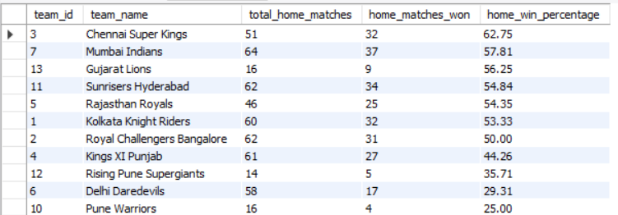

1. **Come up with a visual and analytical analysis of the RCB's past season's performance and potential reasons for them not winning a trophy.**

**Tables used:**

Matches, team, season

**Approach:**

* Filter matches involving Royal Challengers Bangalore (RCB) by joining the team and matches tables.
* Aggregate match data season-wise to calculate total matches played, matches won, and matches lost by RCB.
* Calculate the win percentage for each season.
* Join with the season table to get readable season year details.
* Order results by season year to analyze performance trends over time.

**Insights:**

* **Inconsistent Win Percentage:** RCB’s win percentage varies significantly season-to-season, indicating inconsistency.
* **Matches Won vs Lost Gap:** The difference between matches won and lost does not show a steady upward trend.
* **No Trophies Despite High Talent:** Even in seasons with decent win percentages, RCB has not won the trophy.
* **Possible Clutch Performance Issues:** Lack of converting good performances into tournament wins could indicate problems in knockout stages or pressure situations.

**Potential Reasons for Not Winning a Trophy:**

1. **Inconsistent Team Performance:**
   * Fluctuating win percentages show that team performance isn't stable.
2. **Key Player Injuries:**
   * Star players might have missed critical matches reducing overall team strength.
3. **Pressure in Knockout Matches:**
   * Possible struggles in high-pressure knockout games impacting chances of winning the trophy.
4. **Lack of Balanced Team Composition:**
   * May lack all-rounders or depth in either batting or bowling during crucial moments.
5. **Strategic Decisions:**
   * Toss decisions, team selection, or game strategies possibly not optimized for match conditions.
6. **Home Ground Advantage:**
   * Underutilization of home ground advantage could impact match wins.

**Recommendations for RCB:**

* **Focus on Consistency:** Build a core team that performs steadily across all matches.
* **Strengthen Middle Order & Bowling Depth:** To improve balance and handle pressure situations better.
* **Analyze Knockout Matches:** Identify key weaknesses in high-stake games and strategize accordingly.
* **Use Data-Driven Strategies:** Leverage analytics for player fitness, pitch conditions, and opposition strengths.
* **Capitalize on Home Advantage:** Maximize performance in home venue matches.

**Query:**

with rcb_performance as (

select

m.season_id as season_id,

count(m.match_id) as matches_played,

sum(case when m.match_winner = t.team_id then 1 else 0 end) as matches_won,

sum(case when m.match_winner != t.team_id then 1 else 0 end) as matches_lost,

(sum(case when m.match_winner = t.team_id then 1 else 0 end) * 100.0) / count(m.match_id) as win_percentage

from matches m

inner join team t on t.team_id = m.team_1 or t.team_id = m.team_2

where t.team_name = 'royal challengers bangalore'

group by m.season_id

)

select

s.season_year,

rp.matches_played,

rp.matches_won,

rp.matches_lost,

round(rp.win_percentage, 2) as win_percentage

from rcb_performance rp

inner join season s on rp.season_id = s.season_id

order by s.season_year;

**Output:**

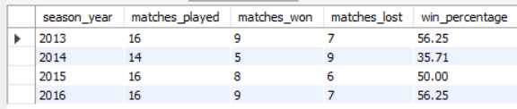

1. **How would you approach this problem, if the objective and subjective questions weren't given?**

**If no predefined questions were provided, I would approach the IPL dataset as follows:**

1. **Understand the Dataset:**
   * Review available tables and columns (players, matches, teams, venues, performance stats).
   * Identify key metrics such as wins, losses, player statistics (batting and bowling), and venue details.
2. **Set Analysis Goals:**
   * Explore team performance trends across seasons (matches played, wins, losses).
   * Identify top-performing players and consistent contributors (batsmen, bowlers, all-rounders).
   * Analyze player performance in high-pressure situations (playoffs, death overs).
   * Assess team strengths and weaknesses (e.g., batting order, bowling at the death).
   * Examine match patterns like impact of toss, batting first vs chasing.
3. **Perform Statistical Analysis:**
   * Match-level: Analyze factors influencing outcomes (toss decision, batting order).
   * Player-level: Evaluate averages, strike rates, economy rates, and all-round contributions.
   * Venue-level: Investigate home-ground advantage effects.
4. **Visualize Insights:**
   * Create charts for season-wise performance, top players, home vs away stats, and toss influence.
   * Use visualization tools like Power BI, Tableau, or Excel.
5. **Provide Recommendations:**
   * Suggest areas for team improvement (e.g., bowling in death overs).
   * Identify players to retain or replace.
   * Advise preparation strategies for pressure matches.

This approach ensures a comprehensive, data-driven understanding of the IPL team’s performance and areas for growth.

1. **In the "Match" table, some entries in the "Opponent_Team" column are incorrectly spelled as "Delhi_Capitals" instead of "Delhi_Daredevils". Write an SQL query to replace all occurrences of "Delhi_Capitals" with "Delhi_Daredevils".**

**Tables used:**

team

**Identify the Issue:**

* There is no column named “Opponent_Team” in the matches table. Query the distinct team names in the team table to find incorrect or inconsistent entries.
* Verify spelling mistakes or naming inconsistencies (e.g., "Delhi_Capitals" vs "Delhi_Daredevils").

**Correct the Data:**

* Use an UPDATE SQL statement to replace all occurrences of "Delhi_Capitals" with "Delhi_Daredevils".
* This correction ensures data consistency and accuracy for future analyses involving team names.

**Query:**

update team

set Team_Name = 'delhi_daredevils'

where Team_Name = 'delhi_capitals';

select * from team;

**Output:**

